**Abstract**

The time plan of this project has been modified multiple times. Both initial time plan and timelines with descriptions are included in this section. The timeline of the project was illustrated first in a markdown file then is managed in a Gantt chart. The Gantt chart was made with Microsoft Excel. By typing in the start period and duration, the chart will show the bar of a corresponding length automatically. The bars in different colours denote different status. Purple refers to complete status, and yellow represents beyond plan. Team 10 utilises this tool to trace and manage the work with plan.

**Initially Estimated Phases**

The team initially made a rough time plan structure with estimated time period after each phase. This time plan functions as a base of the project planning. The team has built a Gantt chart based on this plan and made several modification and addition to it during the development. The phases Research and Design go as planned. However, plan for Implementation was underestimated. Significant modifications were done to this part after the design phase.

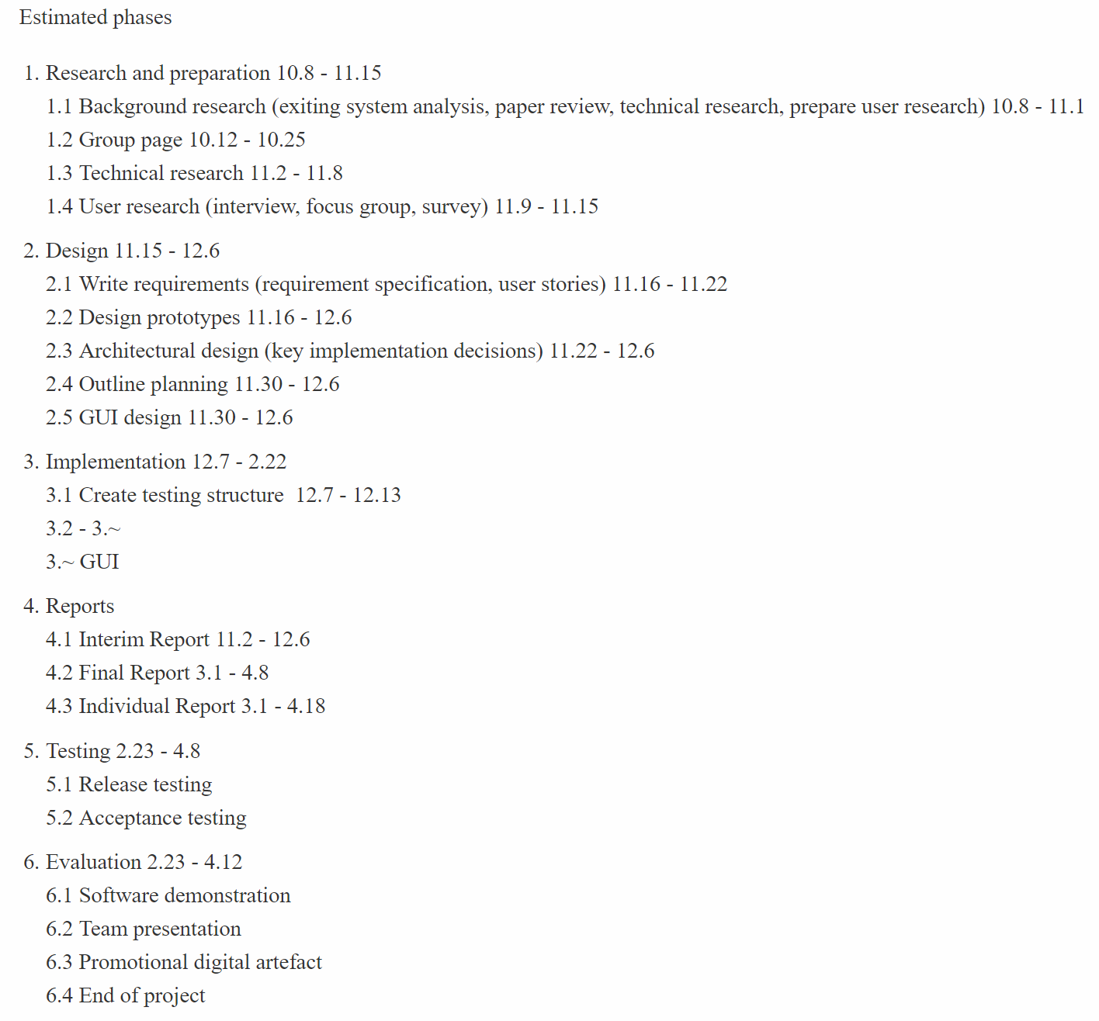

**Gantt Chart**

Figure I.1 is the original plan chart. The team has roughly decided to separate the whole project into six stages and planned several tasks for each stage. Except for reports stage, each stage is depended on the previous one. These stages are presented in the Git project as milestones. As for the Implementation stage, at that point, the team has not decided how to build the software because the requirements gathering process has not finished. After a few weeks' work, the team found the time for requirements gathering and market research was not sufficient. Therefore, some modifications in the research stage have been made. The start date of user research was postponed, and the duration of it was extended.

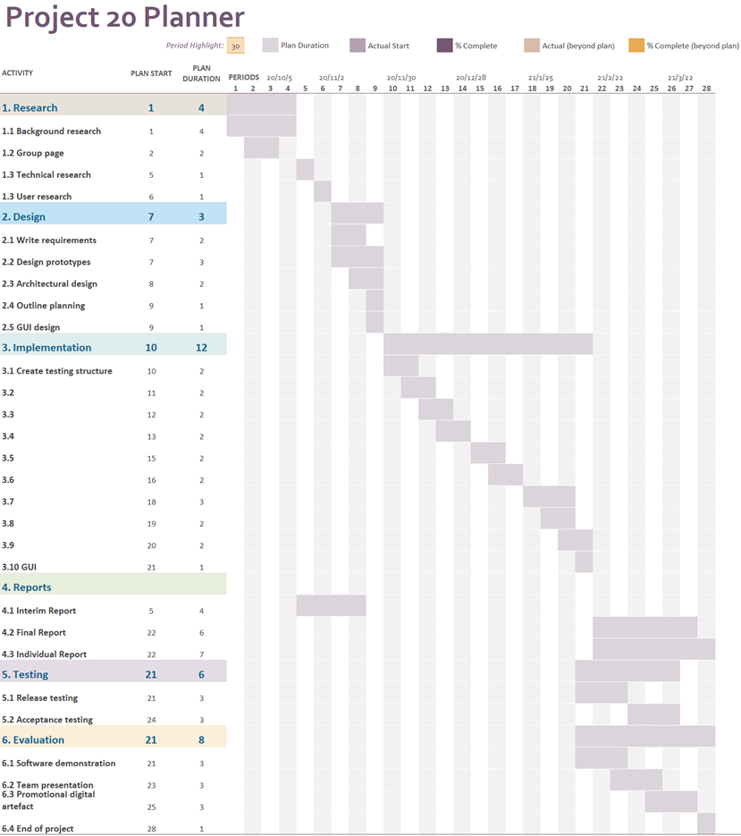

Figure I.1: Original Gantt Chart

On 10th December, the team has finished the interim work mostly as planned. The plan is shown in Figure I.2. Moreover, the detail development plan for implementation has been made. This is illustrated in the third stage. The time plan with Gantt chart helps manage the progress of the project well. The team will utilise this tool in the following weeks to improve the quality of the work.

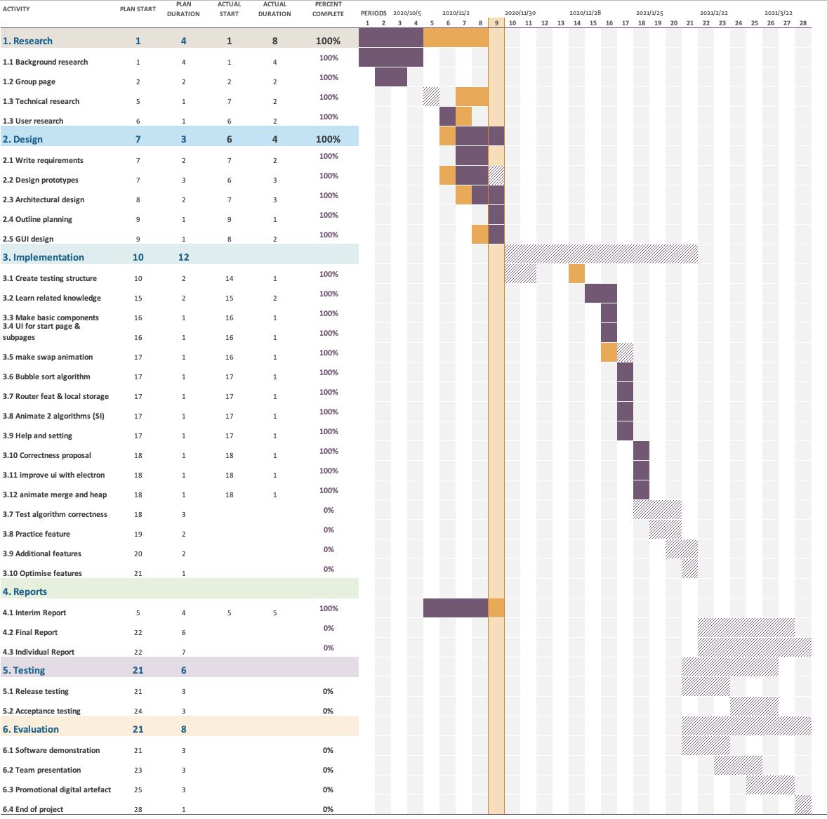

Figure I.2: Interim Gantt Chart

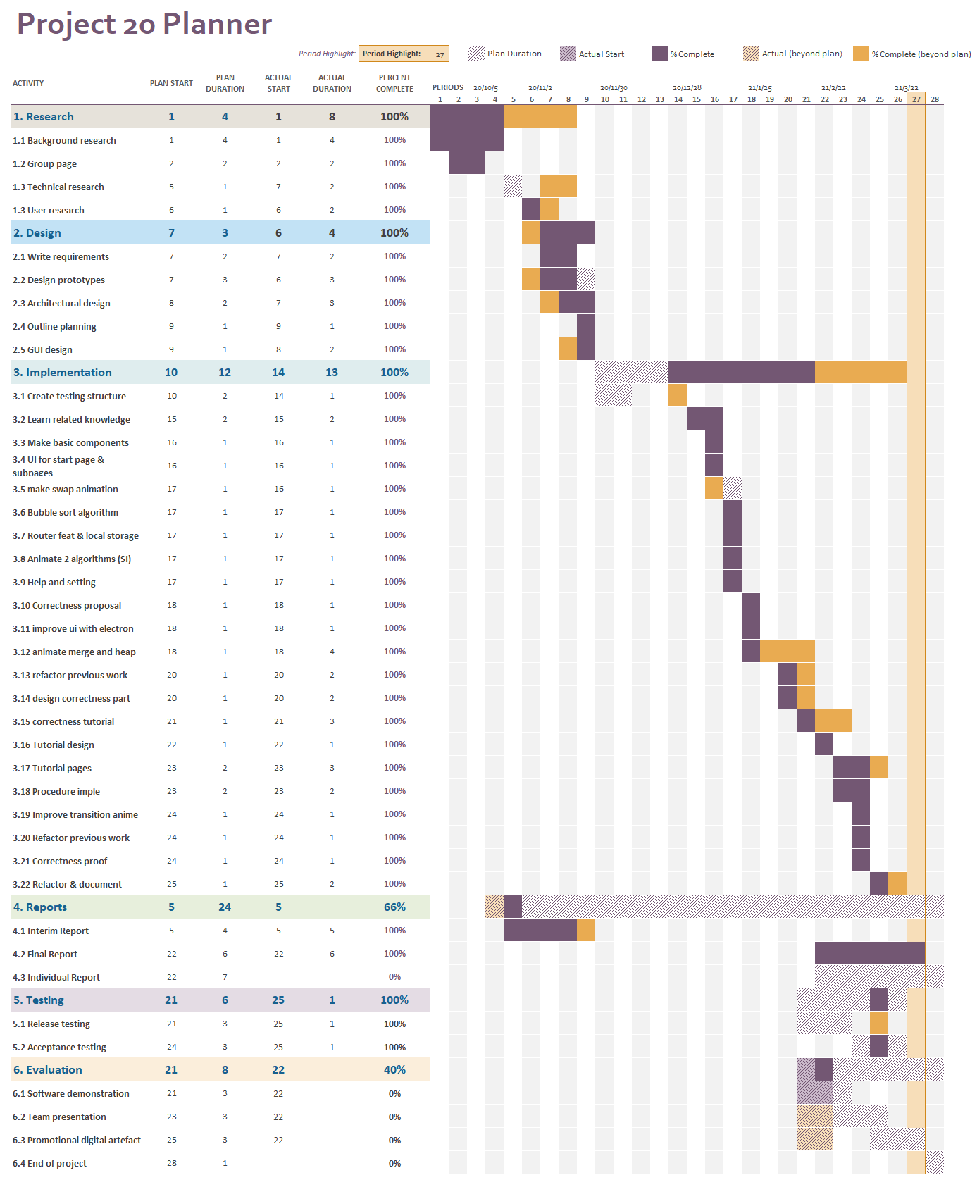

Figure I.3： Time Plan on 9th April

At the end of the stage of software development and final report, the Gantt chart is illustrated in Figure I.3. All the implementation tasks were finished by 4th April. The implementation stage was planned to start on 7th December. However, due to insufficient technical research, it was postponed for four weeks. Although we start coding late, the overall duration was still almost as planned, being 13 weeks. Among 22 tasks in the implementation stage, only seven of them were completed later than planned. The final report was finished as we scheduled. The time plan was overall suitable for the project and guided the team to finish the project on time. As a reflection point, a better performed technical research would result in more time for improving the software and preparing for the presentations.